**Budget Approval System**

**PROPOSED SOLUTION:**

A user interactive website is to be designed where each employee in the organization has an employee account through which he can login. After logging in, the employee can upload the invoice number and amount. When the manager logins to his account, he can view the uploaded bills by the employees. The copy of the approved bills are automatically forwarded to accounts section (financial Manager).

An intimation about the status of the bills in the workflow process can be given via Email. He can also query about status of his request etc.

**Chapter – 2 (System Analysis)**

**REQUIREMENTS:**

* Login Facility.
* Bill Status – Approved, Rejected, Pending, Credited.
* Approval/Rejection by Manager.
* When Status of Bill Changes, Notification is sent to concern employee.
* Type of Bill to be specified by Sender.
* Amount of Bill.
* Option, Whether Bill is backed by Scanned Copy.
* User Roles – Admin, Employee, Manager, Financial Manager.
* Automatic Filling of relevant Fields in Form, like name of sender.
* Date of Bill. Option to Choose Payment Mode.
* In case of Bank Payment Mode: Bank-Name, Address, Account –Number.

**Workflow of Bill through Different Stages**

**PENDING**

**Employee**

**Manager**

**APPROVED**

**Financial Manager**

**Technologies (Open Source / free)**

* ASP.NET MVC – Open source Web Application Framework
* Visual Studio Express
* SQL Server Express
* DOT NET 4.5
* Twitter Bootstrap
* JQuery

**Modules**

* User Management (Login/Registration/Deletion of Users) System.
* Employee Information System.
* Bill Management System.
* Notifications System.

**Architecture**

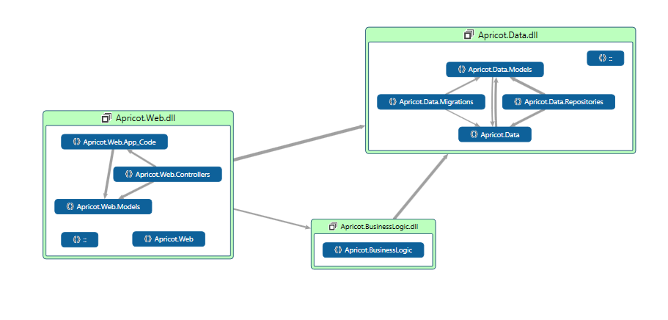

Presentation Layer

Data Layer

Business Layer

**Database Diagram**



**Database Schema (BAS)**

**BAS.Employees**

|  |  |  |
| --- | --- | --- |
| Attribute Data Type Constraints | | |
| Emp_ID | BigInt | Primary Key |
| Emp_No | Varchar(15) | Not Null ,Unique |
| Emp_Name | Varchar(50) | Not Null |
| Is_Active | Boolean | Not Null |
| Dept_ID | BigInt | FK(Departments, Dept_ID) |

**BAS.Employee_Details**

|  |  |  |
| --- | --- | --- |
| Attribute Data Type Constraints | | |
| Emp_ID | BigInt | FK(Employees, Emp_ID) |
| Emp_Address | Varchar(100) | Not Null |
| Emp_Contact_No | Number | Not Null |
| Emp_Gender | Character | Not Null |

**BAS.Bills**

|  |  |  |
| --- | --- | --- |
| Attribute Data Type Constraints | | |
| Bill_ID | BigInt | Primary Key |
| Bill_Status | ENUM (“PENDING”, “APPROVED”, “REJECTED”, CLOSED”) | Not Null |
| Emp_ID | BigInt | FK(Employees,Emp_ID) |

**BAS.Bill_Details**

|  |  |  |
| --- | --- | --- |
| Attribute Data Type Constraints | | |
| Bill_ID | BigInt | PK, FK(Bills, Bill_ID) |
| Bill_Amount | Money | Not Null |
| Bill_Date | DateTime | Not Null |
| Bill_Type | Varchar(50) | Not Null |
| Bill_ModeOfPayment | ENUM (“ACCOUNT TRANSFER”, “CHEQUE”) | Not Null |
| Bill_have_SCopy | Boolean | Not Null |

**BAS.Bills_SCopies**

|  |  |  |
| --- | --- | --- |
| Attribute Data Type Constraints | | |
| Bill_ID | BigInt | PK, FK(Bills, Bill_ID) |
| Bill_SCopy | Image | Not Null |

**BAS.Bill_FM**

|  |  |  |
| --- | --- | --- |
| Attribute Data Type Constraints | | |
| Bill_FM_ID | BigInt | PK,FK(Employees,Emp_ID) |
| Bill_ID | BigInt | FK(Bills, Bill_ID) |

**BAS.Bill_M**

|  |  |  |
| --- | --- | --- |
| Attribute Data Type Constraints | | |
| Bill_M_ID | BigInt | PK,FK(Employees,Emp_ID) |
| Bill_ID | BigInt | FK(Bills, Bill_ID) |

**BAS.Accounts**

|  |  |  |
| --- | --- | --- |
| Attribute Data Type Constraints | | |
| Emp_Id | BigInt | PK, FK(Employees, Emp_ID) |
| Account_No | Number | Not Null, Unique |
| Bank_ID | BigInt | FK(Banks, Bank_ID) |

**BAS.Banks**

|  |  |  |
| --- | --- | --- |
| Attribute | Data Type | Constraints |
| Bank_ID | BigInt | Primary Key |
| Bank_Name | Varchar(75) | Not Null |
| Branch_Name | Varchar(75) | Not Null |
| Branch_City | Varchar(50) | Not Null |

**BAS.Comments**

|  |  |  |
| --- | --- | --- |
| Attribute Data Type Constraints | | |
| Cmt_ID | BigInt | Primary Key |
| Cmt_Subject | Varchar(100) | Not Null |
| Cmt_Body | Varchar(1000) | Not Null |
| Bill_ID | BigInt | FK(Bills, Bill_ID) |

**BAS.Notifications**

|  |  |  |
| --- | --- | --- |
| Attribute Data Type Constraints | | |
| Ntf_ID | BigInt | Primary Key |
| Ntf_Subject | Varchar(100) | Not Null |
| Ntf_Body | Varchar(1000) | Not Null |
| Ntf_Seen | Boolean | Not Null |
| Ntf_Emp_ID | BigInt | FK(Employees,Emp_ID) |

**BAS.Departments**

|  |  |  |
| --- | --- | --- |
| Attribute Data Type Constraints | | |
| Dept_ID | BigInt | Primary Key |
| Dept_Name | Varchar(50) | Not Null |